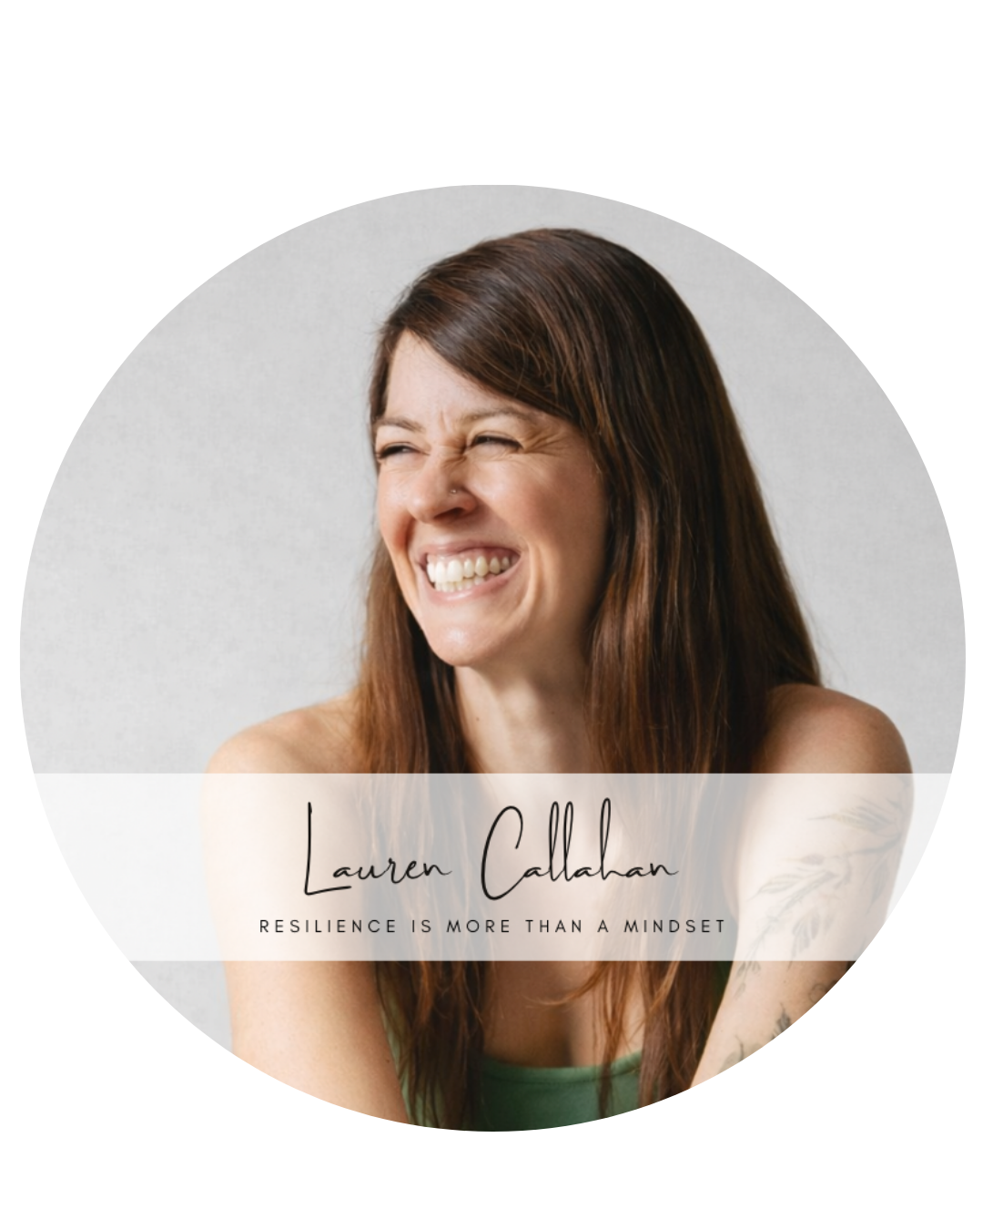
Lauren Callahan
lauren@laurenbcallahan.com
318.589.8021

Keynote/Workshop
Fix Your 2pm Crash
Energy Without the Can: A Science-Backed System for
Focus, Mood, and Performance

Abstract
Most high-performing teams don’t lose productivity because they lack discipline—they lose it because they’re running on unstable biology. The 2pm crash has become normal in corporate culture, driving increased reliance on caffeine, energy drinks, sugar, and “powering through,” while quietly reducing focus, decision quality, creativity, and resilience.
In this high impact workshop, Lauren explains the real drivers behind chronic fatigue: inflammation, cortisol dysregulation, blood sugar instability, and gut dysfunction— issues that are often amplified by the physiological changes of midlife. Many common strategies professionals rely on (skipping meals, extreme dieting, over-caffeinating, and ultra-processed “health” foods) actually worsen fatigue, mood instability, and burnout.
Through compelling storytelling and practical performance physiology, Lauren teaches a realistic energy framework that leaders can implement immediately to stabilize energy and reduce inflammation. Audiences will be equipped with actionable tools to improve energy, focus, and performance—starting the same day.
“Lauren’s expertise resonated deeply with our audience, making it my highest-rated event to date.”
–Ray Doustdar, host of the Deep Shallow Dive podcast

Learning Objectives
- Understand how gut health and inflammation impact energy, mood, and performance.
- Apply a simple 5-part framework to stabilize energy and eliminate the 2pm crash.
- Identify the 4 most common habits that sabotage cortisol, sleep, and metabolism.
- Implement 3 high-impact strategies to improve energy and focus within 7 days.

References
Christy Pennison, LPC-S; Founder & CEO, Be Inspired Counseling & Consulting; Speaker & Podcast Host of the Inspiring Possible Podcast; Co-Founder, The Practice Collab; christy@beinspiredcc.com; (318) 541-8380

Ray Doustdar, host of the Deep Shallow Dive podcast, ray@deepshallowdive.com, 310-283-7293

