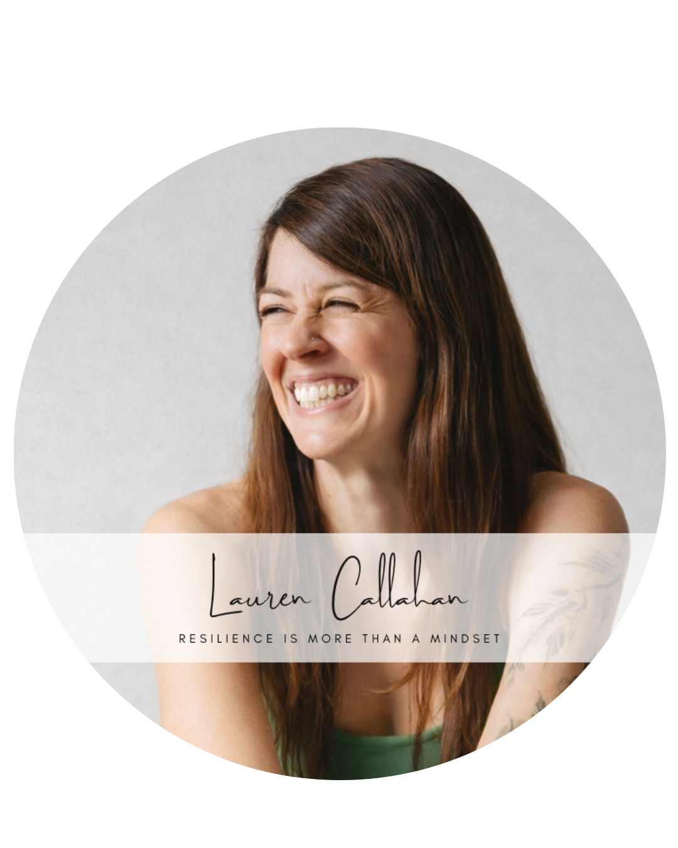
Lauren Callahan
lauren@laurenbcallahan.com
318.589.8021

Keynote/Workshop
Resilience is More Than a Mindset:
A 4-Part Framework to Build Energy, Focus,
and Leadership Capacity

Abstract
Resilience is often treated like a mindset—something leaders should be able to “think” their way into. But real resilience isn’t purely psychological. It’s biological. It’s behavioral. And it’s built through the daily practices that shape focus, energy, and emotional regulation.
In this high-impact keynote, Lauren Callahan challenges the modern definition of resilience and introduces a practical 4-part framework for building it from the inside out. Audiences will learn how resilience is strengthened through what we write (clarifying vision and reducing decision fatigue), what we eat (stabilizing blood sugar, reducing inflammation, and supporting the nervous system), how we move (building stress tolerance, strength, and mental clarity), and how we grow (taking courageous action that expands identity and leadership capacity).
Through compelling storytelling and actionable performance science, Lauren equips leaders with a simple system they can implement immediately to build real resilience—measurable in focus, energy, and performance—starting the same day.
“Lauren’s expertise resonated deeply with our audience, making it my highest-rated event to date.”
–Ray Doustdar, host of the Deep Shallow Dive podcast

Learning Objectives
- Learn a practical 4-part framework for building mental, emotional, and physical resilience.
- Understand why resilience is not simply a psychological strategy or personality trait.
- Identify the 3 top nutritional habits to empower deep, lifelong resilience.

References
Christy Pennison, LPC-S; Founder & CEO, Be Inspired Counseling & Consulting; Speaker & Podcast Host of the Inspiring Possible Podcast; Co-Founder, The Practice Collab; christy@beinspiredcc.com; (318) 541-8380

Ray Doustdar, host of the Deep Shallow Dive podcast, ray@deepshallowdive.com, 310-283-7293

